
Port Seton Resource Centre Newsletter 2014 (1)

“Recent Events”

Port Seton Resource Centre Conference
“Moving On”


The Members Council held it's first ever conference in February and very successful it was too. Registration, breaks, invited speakers, everything. The subject - Moving On - was chosen as a number of people were interested in how they could become more independent and perhaps one day get their own, or shared accommodation. Invited speakers provided information on benefits and working opportunities. A video based on one man’s personal experiences was screened. There was loads of information and it was all a bit complicated for some but what was nice was the amount of support and good wishes expressed to those already setting out on this journey. Well done everybody. Please go to our web site to see our pictures and video of this event.
http://psrc.org.uk/index.php/2014-events/489-conference-2014-moving-on

Port Seton Community Centre and Resource Centre Open Day
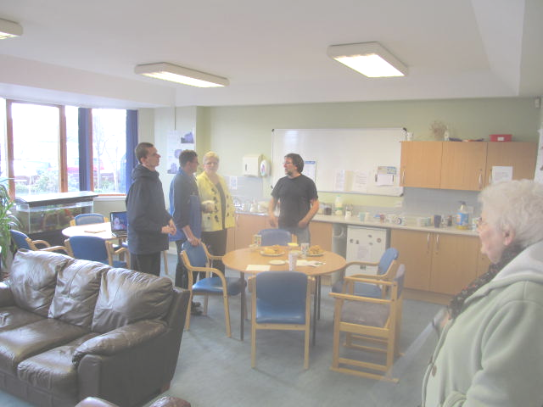
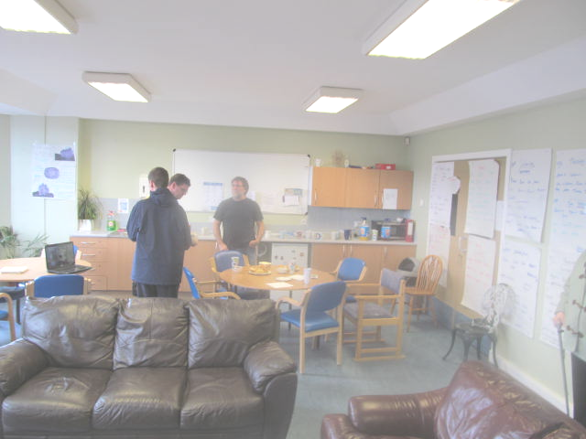
The joint Open Day in March was a middling success. We feel it’s a nice chance for parents and carers to catch up over a scone and tea but we didn’t get a great response this time. There was some music, dance and art being demonstrated around the community centre for your enjoyment or even for your participation.

Port Seton Resource Centre and Borders College Graduation Night

It’s always a pleasure to see people taking the time and making the effort to come along and support our service users on these special occasions and tonight was an exceptional and brilliant affair. Fiona Breckenridge from Borders College presented all the certificates and medals for all the hard work and effort put in to their chosen studies. What a night, Magic.
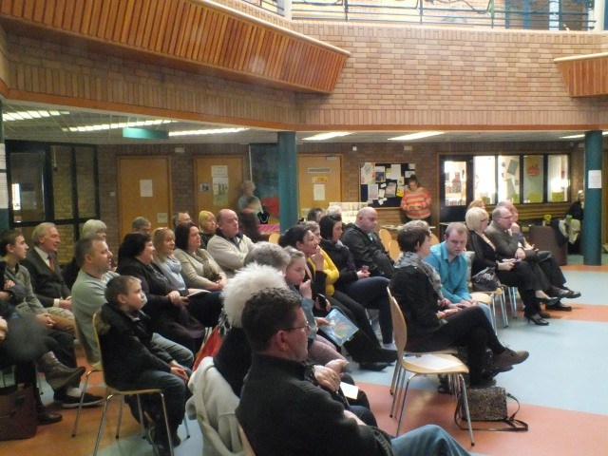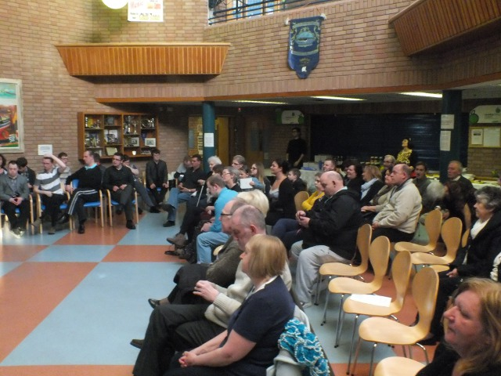

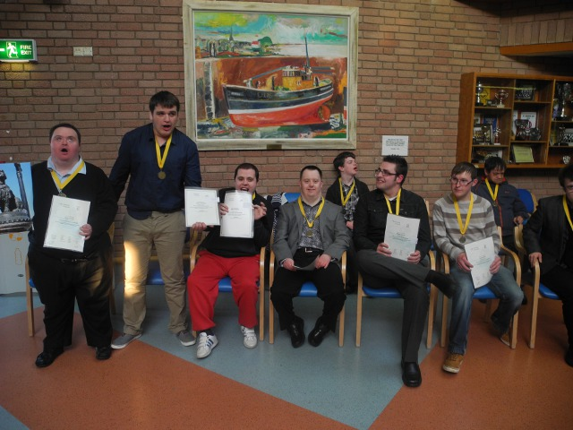



SURVEY SURVEY SURVEY!!!
We are the surveyors – it’s official!

Parents and Carers Telephone Survey, Feb 2014

Our general impression from this year’s telephone survey is that maybe there is a bit of communication overload going on but no one is crying out for more. No one system of communication is going to suit everybody but each variety of method we use seems to be appreciated and used by some. The main factor that most people feel they benefit from is our accessibility and our approachability.

33 out of the 39 people contacted gave us responses to our 4 questions, with a magnificent 90+% responses being positive. Thanks for all the lovely comments of appreciation. (See below)

“Always accessible”, “The centre is great”, “Communication very good”, “Doing a great job”, “Really happy with the service”

Service User Survey, March 2014



Firstly, thanks to all who contributed or participated in our survey. We used the “Talking Mats” system of HAPPY, SAD and DON’T KNOW symbols where required to aid communication. From our results I’m glad to say it looks like there is a very high level of satisfaction (95%) with the staff at Port Seton.

Staff Survey, April 2014
With all these surveys on the go we couldn’t miss out on our very own staff. Thanks for everyone’s participation and I’m sure it will come as a bit of a relief to some but we do appear to be a bit normal. Phew.
INFORMATION

Social Night - Bowling Club Summer Bash
Our next social will be on Friday 13th June, 2014. 7:00 till 10:00.
I’m not superstitious but!!! Here’s hoping for another great night, touch wood. £10 for music and food.

Summer Programme
The summer programme will run again through July and August. As usual we will try to take advantage of the nicer weather and get out as much as possible.

College Courses
Borders College will be looking to enrol new students in summer/autumn. Please let staff know if anyone is interested.

Port Seton Resource Centre Web Site
As ever information on recent and previous groups and activities can be found by using our web site.
Here is the URL: http://psrc.org.uk/

Fixed Public Holidays:
Friday 12th September 2014
Monday 15th September 2014
Thursday 25th December 2014 to Friday 2nd January 2015 inc.

Contact Details:
Phone : 01875 818175
Email : cmaclean1@eastlothian.gov.uk
Email : bsmith@eastlothian.gov.uk
Pin this on the fridge for easy reference

Fisherrow Hub Evening Drop-In Dates and Times
An evening of fun, relaxation and social activities. Dates for Fisherrow Hub are:

- Thursday 1st, 15th and 29th May 2014 6:30 to 8:30
- Thursday 12th and 26th June 2014 6:30 to 8:30
- Thursday 10th and 24th July 2014 6:30 to 8:30
- Thursday 7th and 21st Aug 2014 6:30 to 8:30
- Thursday 4th and 18th Sept 2014 6:30 to 8:30
- Thursday 2nd , 16th and 30th Oct 2014 6:30 to 8:30
- Thursday 13th and 27th Nov 2014 6:30 to 8:30
- Thursday 11th Dec 2014 6:30 to 8:30

Carer Group Request
My name is John Buckley and my son attends PSRC. We are once again asking people to consider forming a carers group. There has been little interest in the past, but recently, there has been changes made to transport and there are issues regarding SDS, respite and lots of other things that as a group, we could discuss and make representation at meetings. The plan is to join up with carers from Tynebank and possibly Fisherrow. I currently attend Day Service redesign and Learning Disability Group meetings on your behalf, but I have been unable to pass any information on due to not having a carers group. I would urge you to really consider joining as this is just the start of many changes coming your way and we need to be involved in all decisions that concern any changes to PSRC. There would only be meetings every 2 or 3 months, but these meetings would hopefully be of use to all with up to date information and even could be done by email. My contact details are johncbuckley@hotmail.co.uk and 07747538120. Thanks.

